DEPLOYMENT FOR JENKINS APPLICATION IS CREATED

Deployment.yaml has necessary instructions to launch a jenkins in K8 pod.

- Kubectl create -f deployment.yaml –namespace muthu

- Kubectl get deployment –namespace muthu ( see a deployment is created )
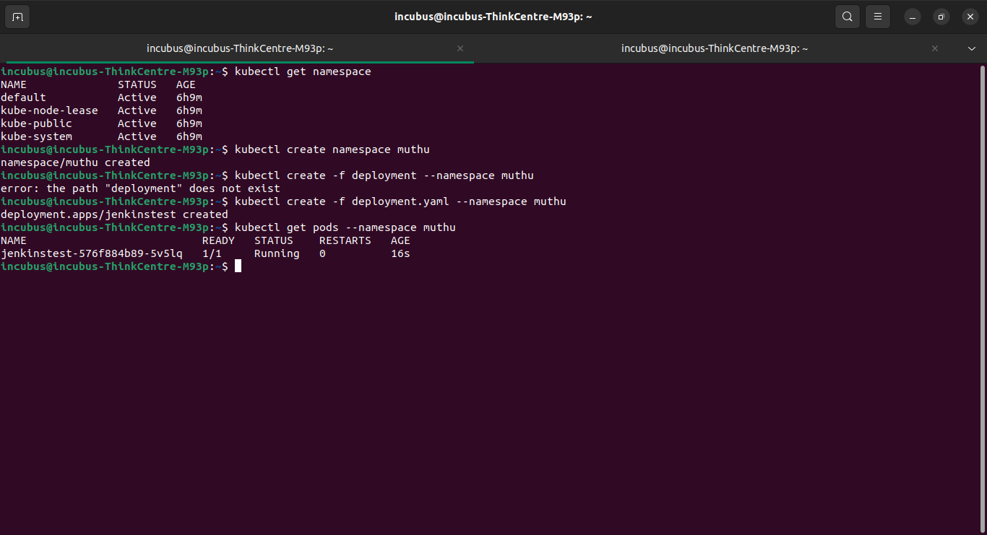
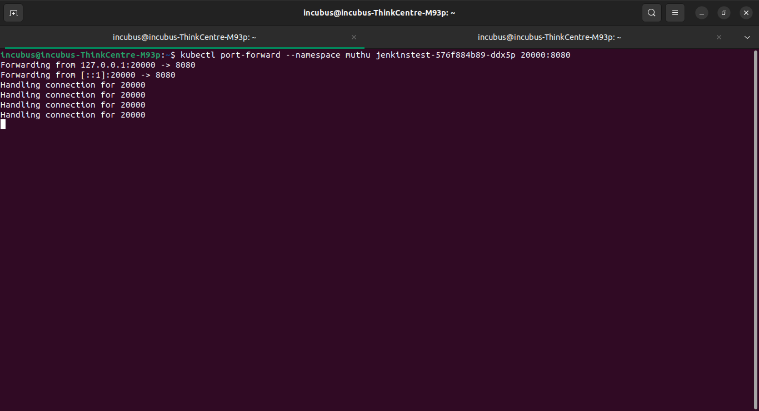
- Port forwarded to see the output

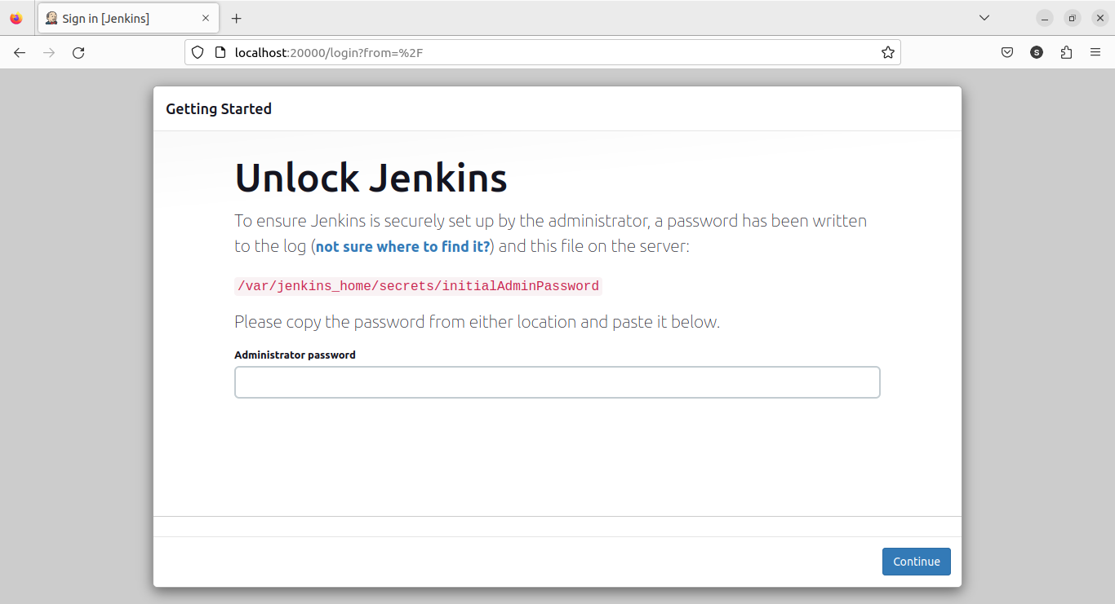
Jenkins running in the local host look at the port.

